B. Eshghieh, PM. Klingsberg, G. Lin, D. Park

DSO 545 – Final Project

VISUALIZING A DIGITAL MEDIA PLATFORM

*Please note that we have been asked to not include the name of the streaming service we are analyzing in our final report. For the purposes of this project, throughout the paper we will refer to the company as “Digital Media Platform” or “DMP”.*

Digital Media Platform is a free, ad-supported streaming service that provides premium content to users straight to their device of choice. DMP content includes original series produced for the service by their parent company, and acquired content including series and movies. DMP is currently available in 21 countries and is accessible to users across multiple devices including mobile, tablet, smart TVs, desktop, and gaming consoles. DMP’s revenue stream comes from users watching ads on the platform while they are viewing content, which is what allows for the service to be entirely free.

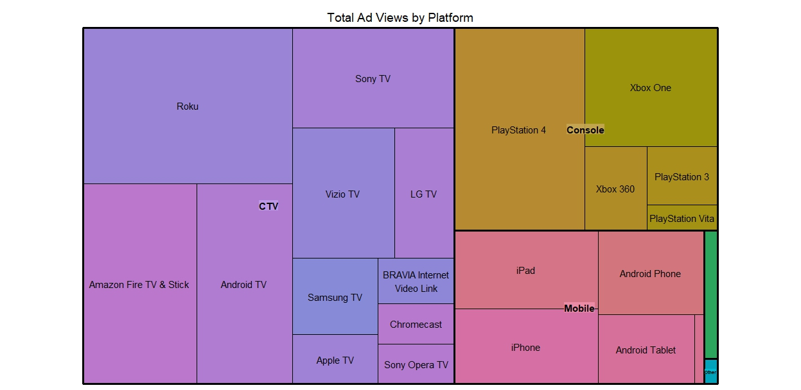

**THE ABOVE REPRESENTS ALL THE DIFFERENT PLATFORMS THAT DMP IS VIEWED ON AND**

**WHERE THE MOST ADS ARE SEEN**

For our final project, our objective was to analyze and understand the following:

* **User Monetization**: Gain an understanding of the revenue generated per customer in order to produce forecasting for future revenues. Is there any seasonality? Is there any correlation among an increase in registered users generating an increase in revenue?
* **Content Performance**: Minutes per stream indicates how long a unique user stays on the content. Are users watching content for a significant amount of time?
* **Platform Performance**: The amount of users on the platform indicates higher/lower usage. Where should DMP increase platform development and allocate more engineering resources?

In order to gain an understanding of DMP’s user monetization, content performance, and platform performance, we used two different data sets. The first data set was DMP user data. This data set gave us a month-by-month snapshot of what devices people are using to stream DMP content and for how long they are watching. The user data set included (but was not limited to the following fields):

* **Platform Name** – the type of device that is used to stream DMP
* **Uniques** – the number of unique users
* **Minutes** – the number of minutes that have been watching on a specific device

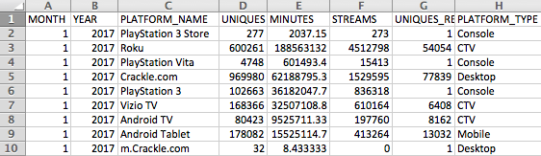

**SNAPSHOT FROM USER DATA**

The second data set was advertising data. This data set included the type of device that DMP content was being streamed on and how many times an ad would be viewed. The ads data set included (but was not limited to) the following fields:

* **Site** – From where and what type of device DMP ads are being viewed on
* **O&O Ad Views** – Each time an ad is viewed

Before we could start analyzing the data, we needed to clean up both data sets to make it usable in R Studio. The following was our data cleaning objectives that needed to be executed before analyzing the data:

1. Cleanup and normalize the platform names. For example "DMP XboxOne App Stream - US" and “DMP XboxOne App Stream - Australia" needed to be changed “to Xbox One”.
2. Clean up dates so that they are month, year.
3. Eliminate any non-existent data fields (such as N/A)

Once the data was cleaned and ready to be used, we were able to create various plots such as box plots showing users on each type of platform, line graphs showing DMP users versus registered DMP users, and several different bar graphs.

Below are the 8 different plots we created accompanied by descriptions and key takeaways.

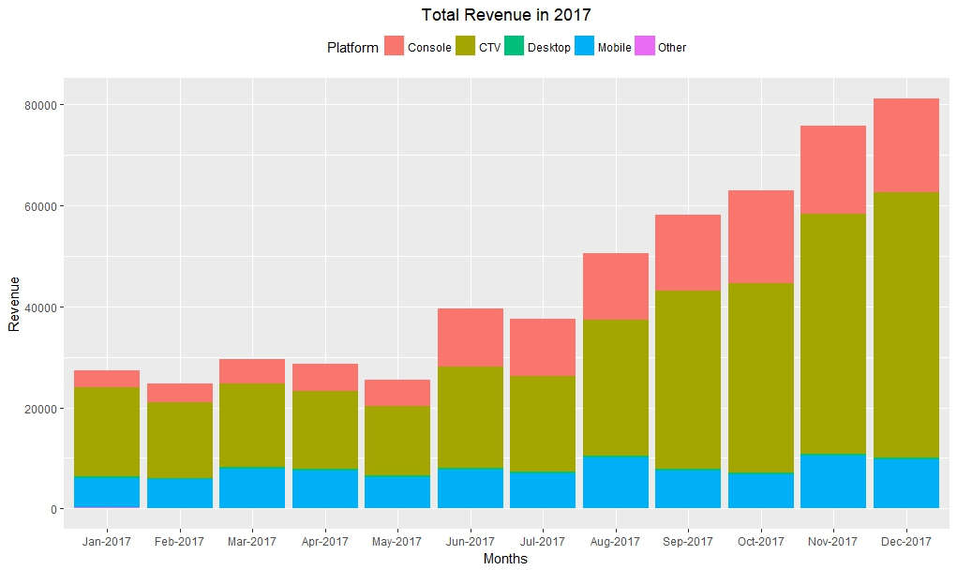

The above bar graph shows the total revenue for DMP by month. Each month you are able to see a breakdown of the different devices that DMP is viewed on. We can see that there is an upward trend in revenue. We observed that the increase in revenue per month is driven by the increase ad views from streaming on CTV’s (Connected TV’s/Smart TVs’). We also noticed that revenue from mobile viewing has held steady all year. This graph helps us to understand **user monetization**. CTV is generating the most revenue for DMP and continues to increase per month. If we were able to access data for another year, we would be able to gain a better understanding of if there is any seasonality.

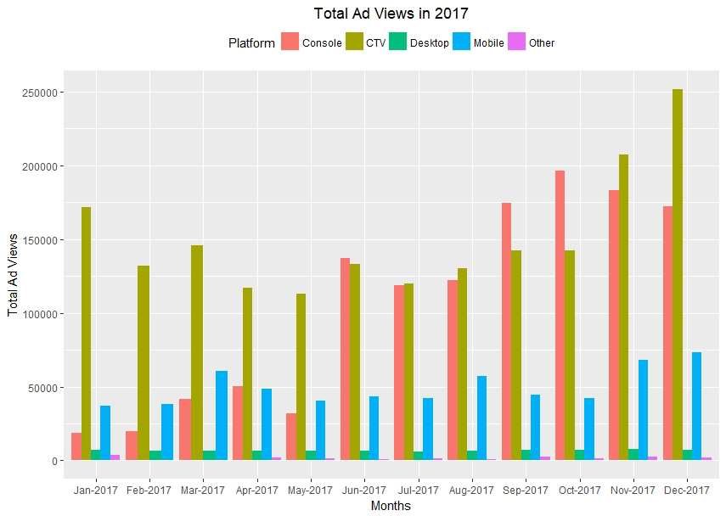

The above bar graph shows total ad views per month broken down by platform type. We can see that as of June 2017 desktop, mobile, and other have the least number of ads viewed on their devices, while more ads are viewed on consoles and CTV’s. Similar to the above graph, this helps us to further understand **user monetization** and draw the conclusion that more revenue is generated from consoles and CTV’s.

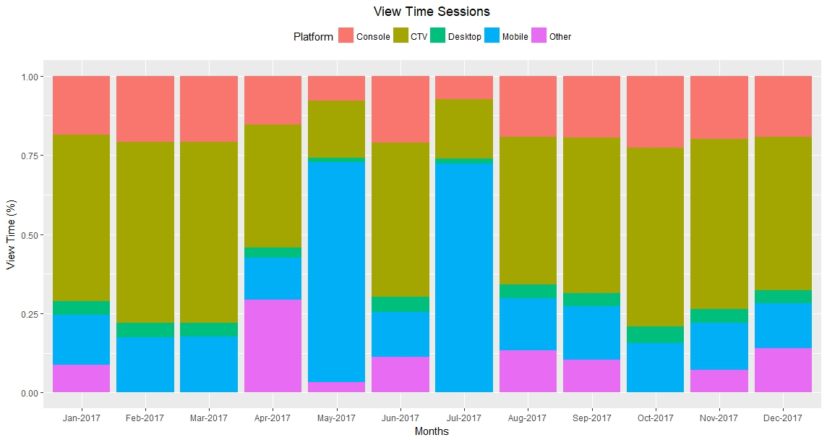

The above graph shows DMP’s view time sessions. In other words, we are able to see what percent of viewing comes from each type of device. Again, we are able to see view time sessions dominating among CTV. This shows us that **content performance** among CTV is strong, while per performance among consoles is weaker.

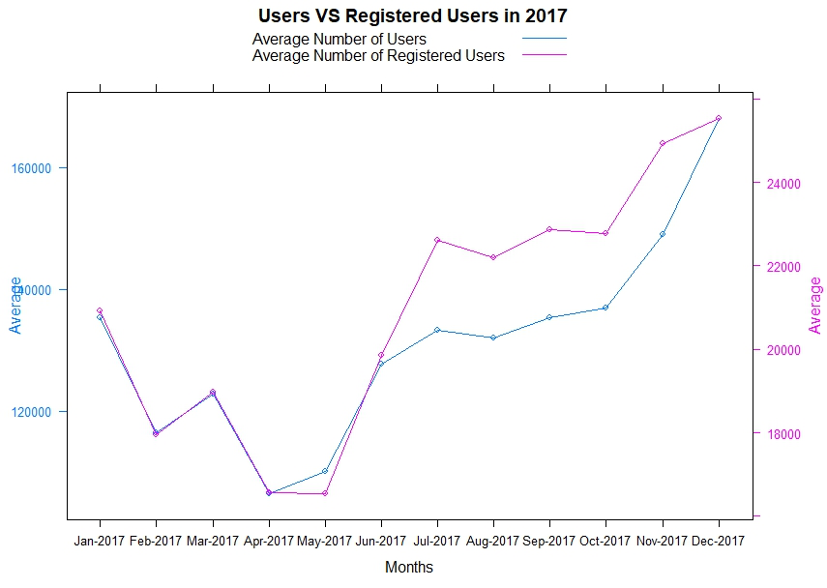

The above graph shows us the difference between registered users and non-registered users. DMP used to have more registered users, but as of December 2017, there is the same number of registered and non-registered users. Previously it could be concluded that **content performance** and **user monetization** was higher with registered users, now there is no difference between registered and non-registered users.

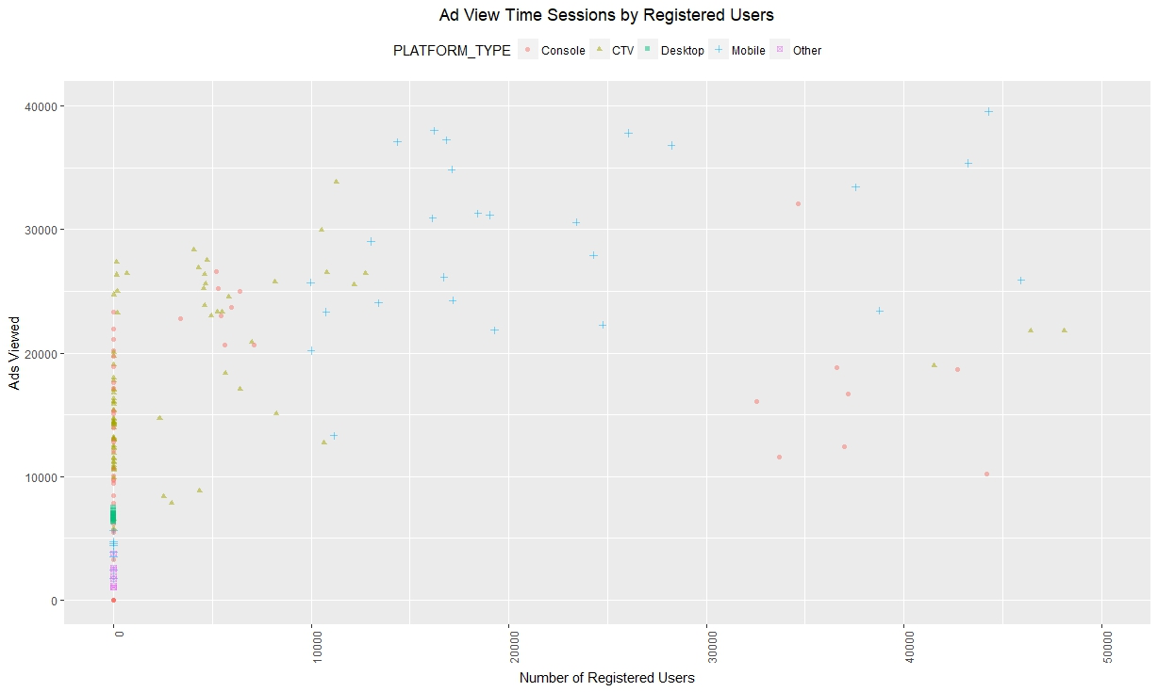

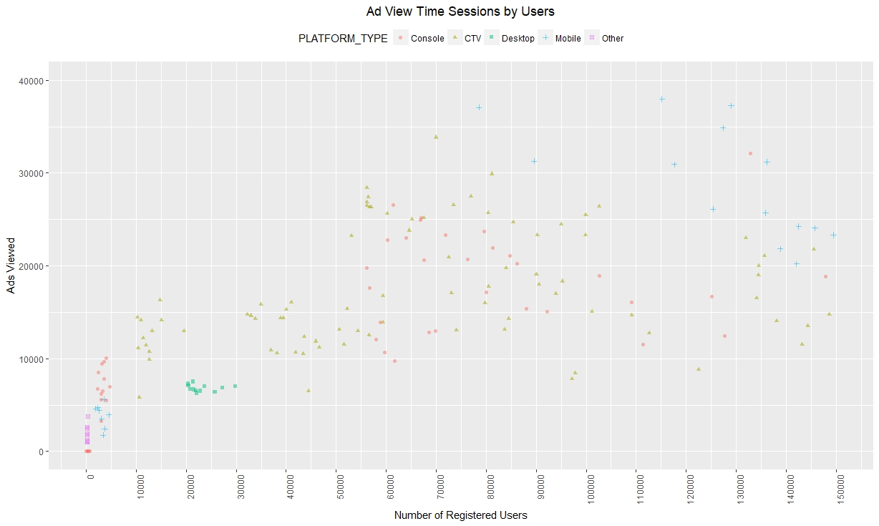

The above two scatter plots show the ad view time by session among registered users and non-registered viewers. We can see that there is a very different pattern between registered and non-registered viewers regarding how many ads are viewed and on what platforms. Among registered users, most ads are viewed on mobile devices; while among non-registered users the ads are mostly viewed between CTV’s and mobile. The above graphs continue to help us understand user monetization and create conclusions.

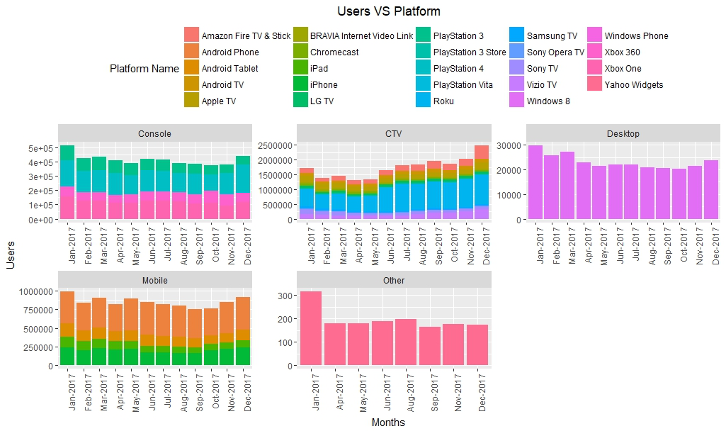

The above graph shows the types of users on each platform. For example you can see among consoles how many are Xbox users and how many are PlayStation users. This graph can help show DMP which devices have the strongest performance on each platform. This helps us to make recommendations regarding platform performance and determine which devices could use extra marketing attention.

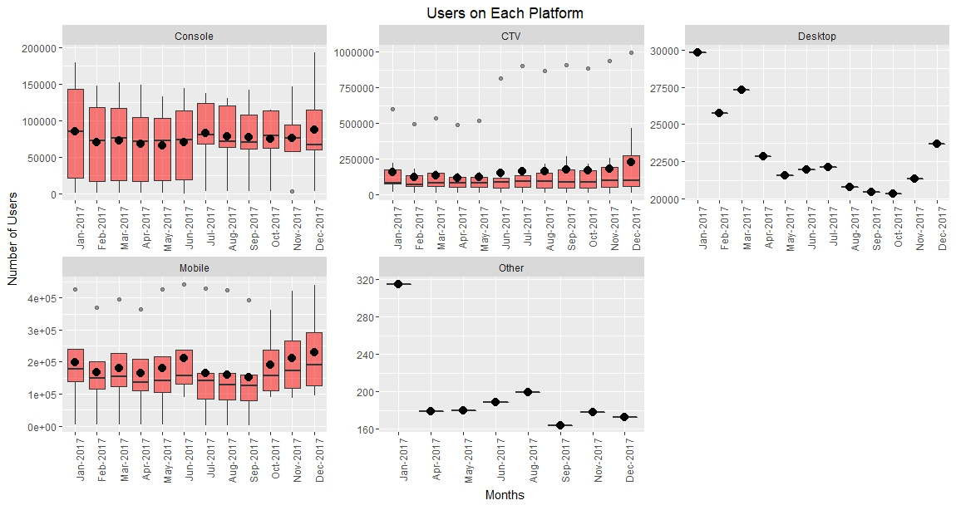

The above box plot is another view of users on each platform. With the above graphs you are able to see the range of number of users each month and where the average lies.

After analyzing the 8 different graphs, we have concluded that ad views among the different platforms vary and that CTV’s bring the most viewers and generate the most revenue for DMP. The above graphs help us to conclude that DMP should put more focus on the user experience on other devices such as mobile and game consoles in order to increase the user presence on these devices.

Our future goal for DMP would be to develop a strategic dashboard for each platform using additional user data so that DMP can have a clear understanding of who their users are on each platform in order to market better towards each of the devices.